Assignment – 3

Write python code for blinking LED and traffic lights for Raspberry pi.

from gpiozero import LED # importing GPIO pins as LED from time import sleep # importing time function as sleep red = LED(18) # red LED is connected to GPIO 18

while True: # infinite loop

red.on() # red LED is on for 1 second sleep(1)

red.off() # red led is off for 1 second sleep(1)

Circuit : LED blinking

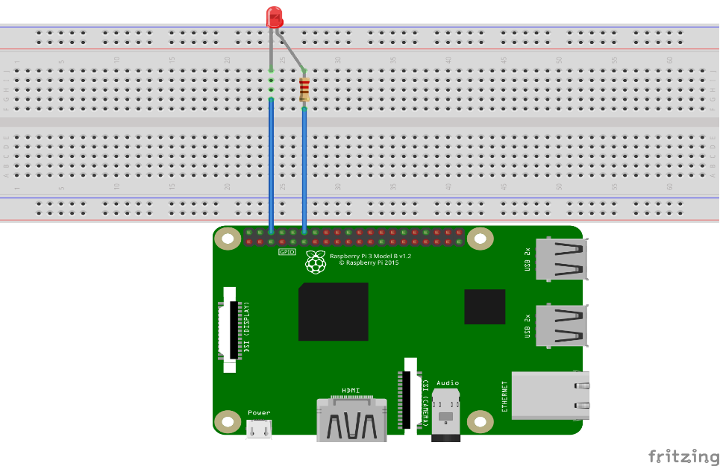

Python code traffic light for raspberry

from gpiozero import LED # importing GPIO pins as LED from time import sleep # importing time function as sleep red = LED(23) # red LED connected to GPIO 23 yellow = LED(07) # yellow LED connected to GPIO 07 green = LED(19) # green LED connected to GPIO 19

while True: # infine loop

red.on() # red LED is on for 5 seconds to make stop sleep(5)

red.off()

yellow.on() # yellow LED is on for 2 seconds to make ready sleep(2)

yellow .off

green.on() #green LED is on for 5 seconds to make go sleep(5)

green.off()

